Compound data

* 2 or more pieces of data that naturally belong together
  + Eg. employee id – employee name, x-coordinate – y-coordinate, etc.

define-struct

* Allows us to create compound values
* Declares definitions
* (define-struct <structure name> (<field names>))

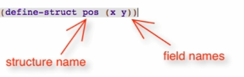

Constructors

(make-<structure name> (<args of the field names>))



Selectors

(<structure-name>-<field-name> <definition>)

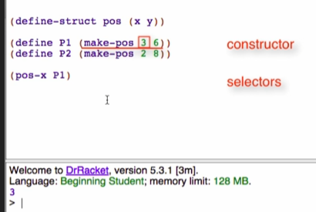

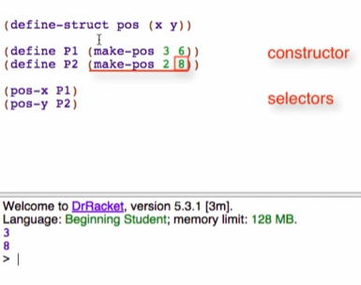

Predicate

(<structure-name>? <definition>)

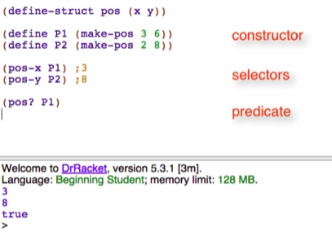

If value is not defined/produced by make-<structure-name>, it will return false

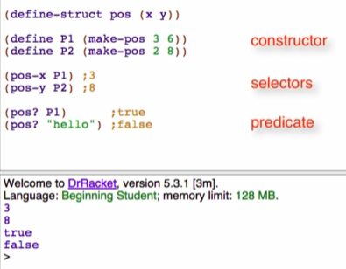

Overview

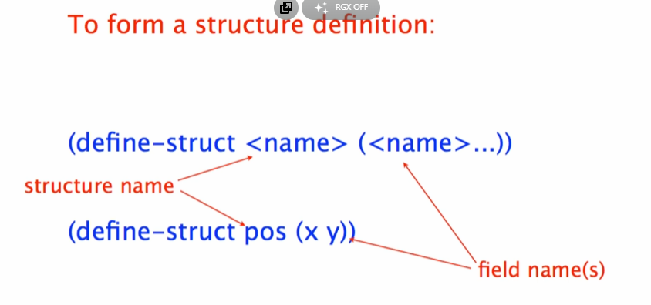

It will setup the following that we can use:

